**Sprint -7 Dotnet with cloud batch**

**Sprint date – 4th to 15th of November, 2019**

**Topic – Learning azure services and practically practicing them.**

**Group D: Inventory Management**

**Microsoft Azure** is a platform as a service (PaaS) solution for building and hosting solutions using **Microsoft's** products and in their data centres. It is a comprehensive suite of **cloud** products that allow users to create enterprise-class applications without having to build out their own infrastructure.

We have created the required Web Application programming interface and we need to deploy it in Azure.

* First we need to sign in into the azure portal.
* Then, we further proceed to create app service and select Web App.
* Select the resource group name from the given list or create a new resource group.
* Then enter the web app name and windows plan for the required region.
* Then click in create and it gets created.

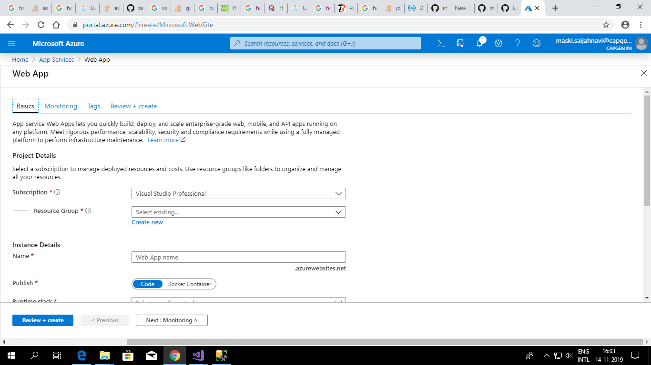

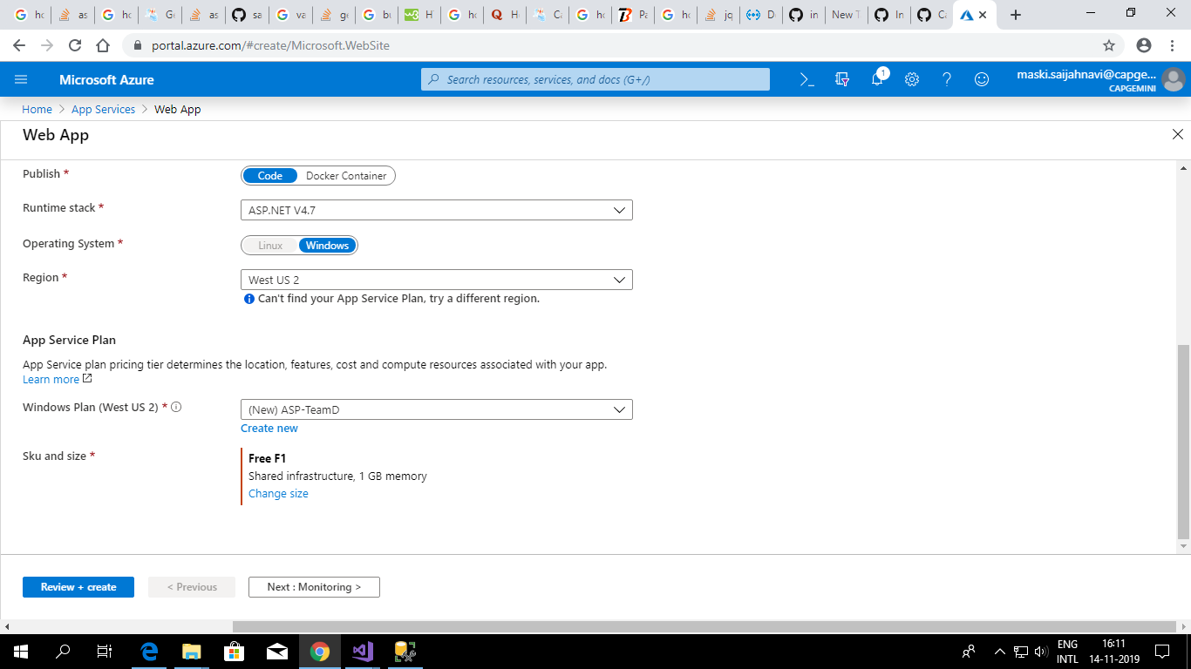

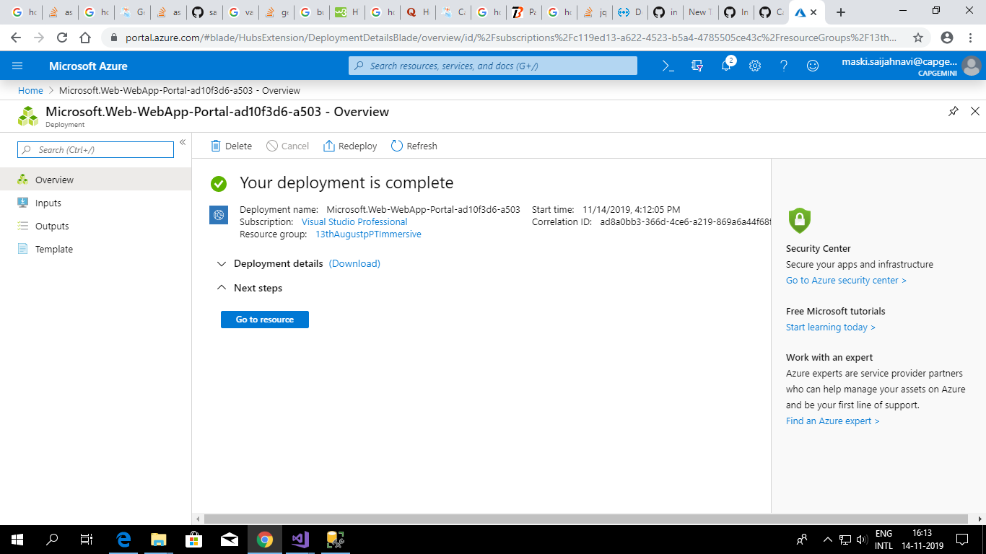

In the last Screenshot, it is mentioned that Your deployment is complete. So, as a result the web app gets created.

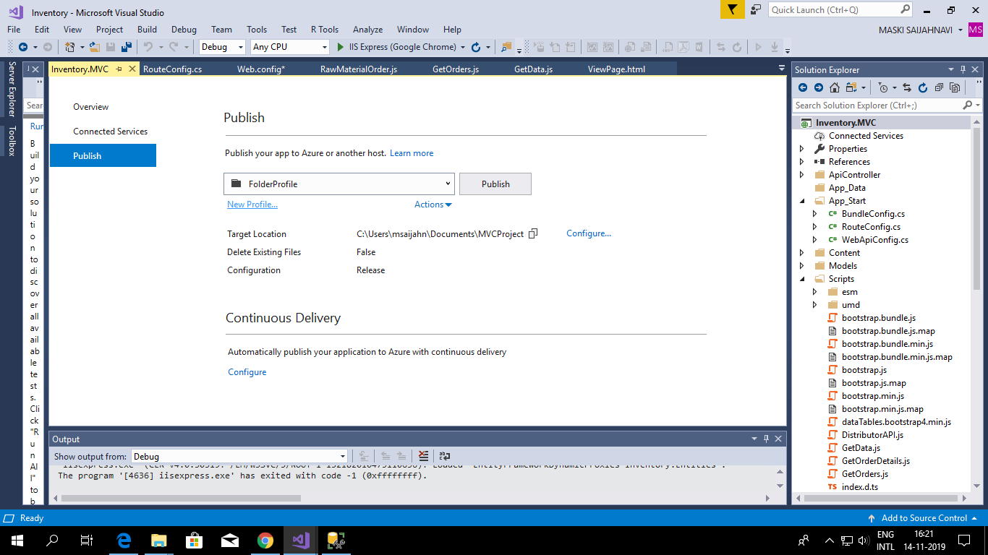

Now, moving on we need to work in visual studio. We need to select the project that we need to deploy on azure and then we click on the required project and select the publish option.

Then, by clicking on new profile and a dialog box appears and in the app service and then go to advanced option. In release Configuration, precompile during publishing and configure again.

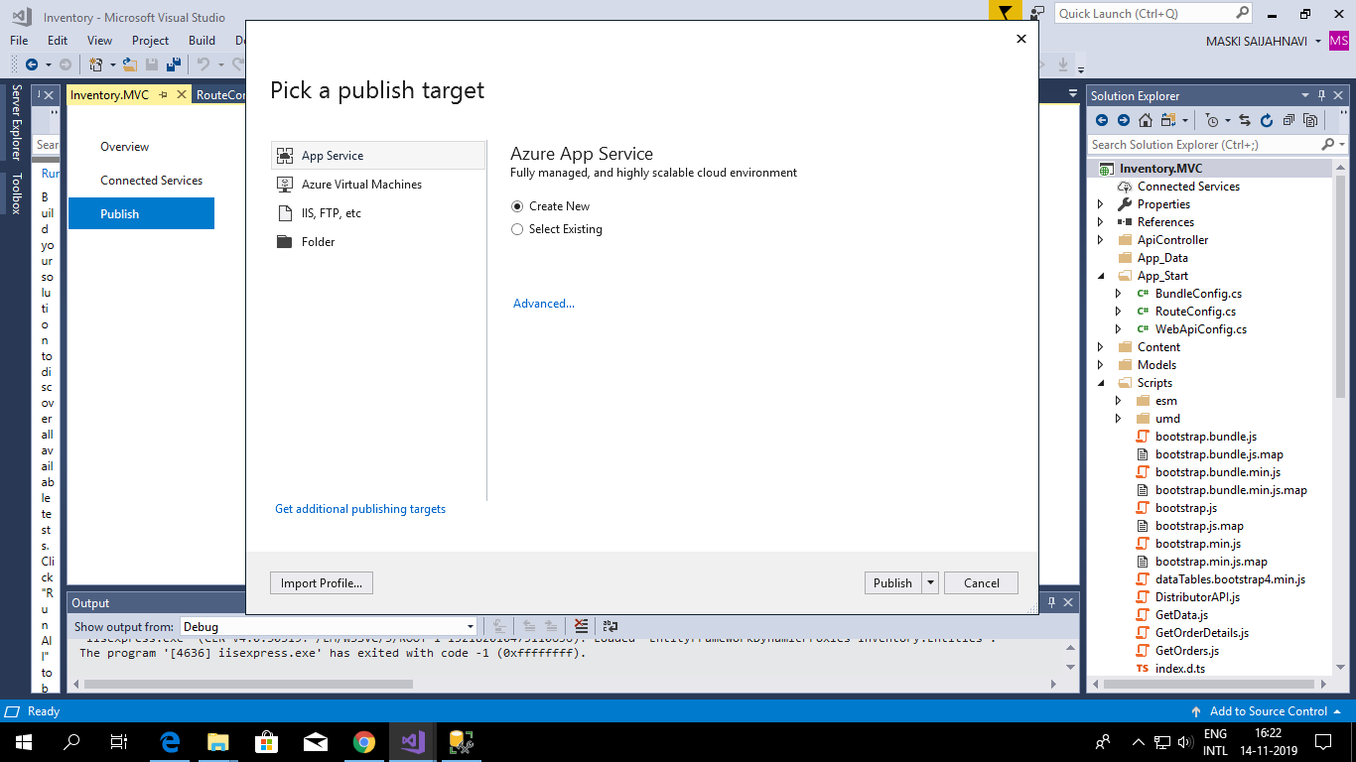

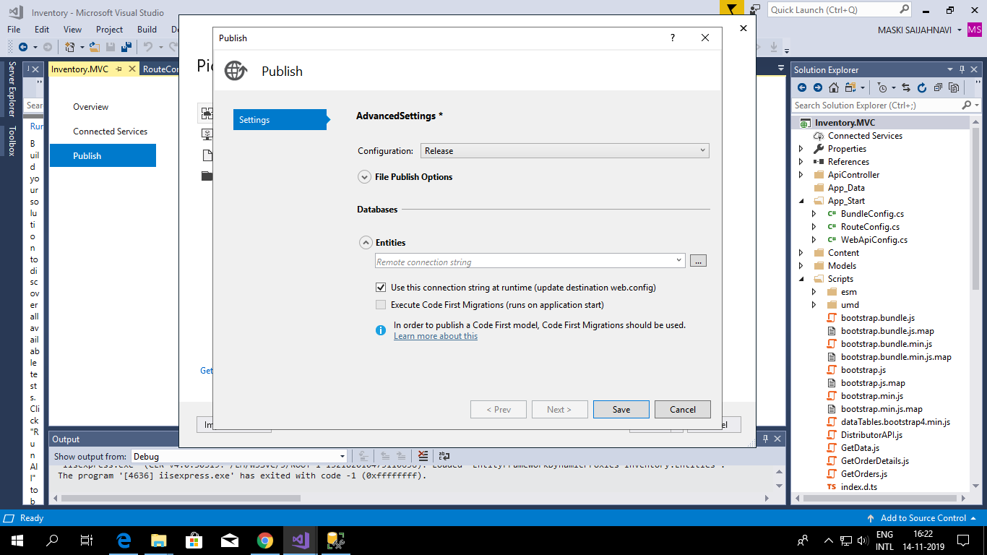

Then we need to copy the connection string of app service so that it gets connected to azure.

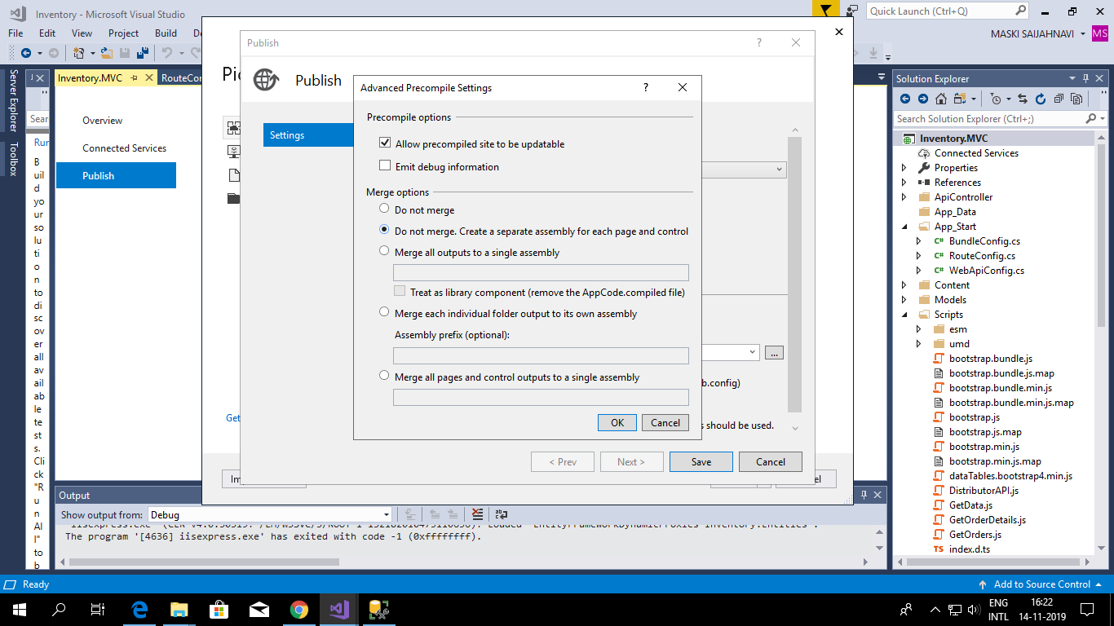

Now, we have to replace the old connection string in the app service with the new connection string.

